1. Dataset - <https://www.kaggle.com/datasets/uciml/glass>
2. Multiple classification - <https://github.com/christianversloot/machine-learning-articles/blob/main/creating-a-multilabel-neural-network-classifier-with-tensorflow-and-keras.md>
3. May be better softmax for multiple classification. Yes – softmax:

<https://towardsdatascience.com/how-to-choose-the-right-activation-function-for-neural-networks-3941ff0e6f9c>

“We must use the softmax function in the output layer of a multiclass classification problem.”

1. Logic: <https://colab.research.google.com/drive/1qovAFIaTaMJzJroCwx20bK1pTBb6e8Uy#scrollTo=9zXRff8tEZcw>.
2. Link to github - https://github.com/kulikofff/Python-Deitel-ML/tree/main/KAGGLE/Deep%20Learning/Multiple%20Classification

***Multiclass classification task with few data.***

Batch Normalization

"Batch normalization" (or "batchnorm") can help correct training that is slow or unstable.

With neural networks, it's generally a good idea to put all of your data on a common scale. The reason is that SGD will shift the network weights in proportion to how large an activation the data produces. Features that tend to produce activations of very different sizes can make for unstable training behavior.

Now, if it's good to normalize the data before it goes into the network, maybe also normalizing inside the network would be better! In fact, we have a special kind of layer that can do this, the **batch normalization layer**. A batch normalization layer looks at each batch as it comes in, first normalizing the batch with its own mean and standard deviation, and then also putting the data on a new scale with two trainable rescaling parameters. Batchnorm, in effect, performs a kind of coordinated rescaling of its inputs.

Capacity

A model's **capacity** refers to the size and complexity of the patterns it is able to learn. For neural networks, this will largely be determined by how many neurons it has and how they are connected together. If it appears that your network is underfitting the data, you should try increasing its capacity.

You can increase the capacity of a network either by making it wider (more units to existing layers) or by making it deeper (adding more layers). Wider networks have an easier time learning more linear relationships, while deeper networks prefer more nonlinear ones. Which is better just depends on the dataset.

Activation function

We must use the softmax function in the output layer of a multiclass classification problem.

Dropout

Dropout can help correct overfitting.

We randomly drop out some fraction of a layer's input units every step of training, making it much harder for the network to learn those spurious patterns in the training data. Instead, it has to search for broad, general patterns, whose weight patterns tend to be more robust.

-------------------------------------------------------------------------------------------------------------------------------

The Optimizer - Stochastic Gradient Descent

We've described the problem we want the network to solve, but now we need to say *how* to solve it. This is the job of the **optimizer**. The optimizer is an algorithm that adjusts the weights to minimize the loss.

Virtually all of the optimization algorithms used in deep learning belong to a family called **stochastic gradient descent**. They are iterative algorithms that train a network in steps. One **step** of training goes like this:

1. Sample some training data and run it through the network to make predictions.
2. Measure the loss between the predictions and the true values.
3. Finally, adjust the weights in a direction that makes the loss smaller.

Then just do this over and over until the loss is as small as you like (or until it won't decrease any further.)

Learning Rate and Batch Size

Notice that the learning process only makes a small shift in the direction of each batch (instead of moving all the way). The size of these shifts is determined by the **learning rate**. A smaller learning rate means the network needs to see more minibatches before its weights converge to their best values.

The learning rate and the size of the minibatches are the two parameters that have the largest effect on how the SGD training proceeds. Their interaction is often subtle and the right choice for these parameters isn't always obvious.

Fortunately, for most work it won't be necessary to do an extensive hyperparameter search to get satisfactory results. **Adam** is an SGD algorithm that has an adaptive learning rate that makes it suitable for most problems without any parameter tuning (it is "self tuning", in a sense). Adam is a great general-purpose optimizer.

Underfitting and Overfitting

There can be two problems that occur when training a model: not enough signal or too much noise. **Underfitting** the training set is when the loss is not as low as it could be because the model hasn't learned enough signal. **Overfitting** the training set is when the loss is not as low as it could be because the model learned too much noise. The trick to training deep learning models is finding the best balance between the two.

Early Stopping

When a model is too eagerly learning noise, the validation loss may start to increase during training. To prevent this, we can simply stop the training whenever it seems the validation loss isn't decreasing anymore. Interrupting the training this way is called **early stopping**.

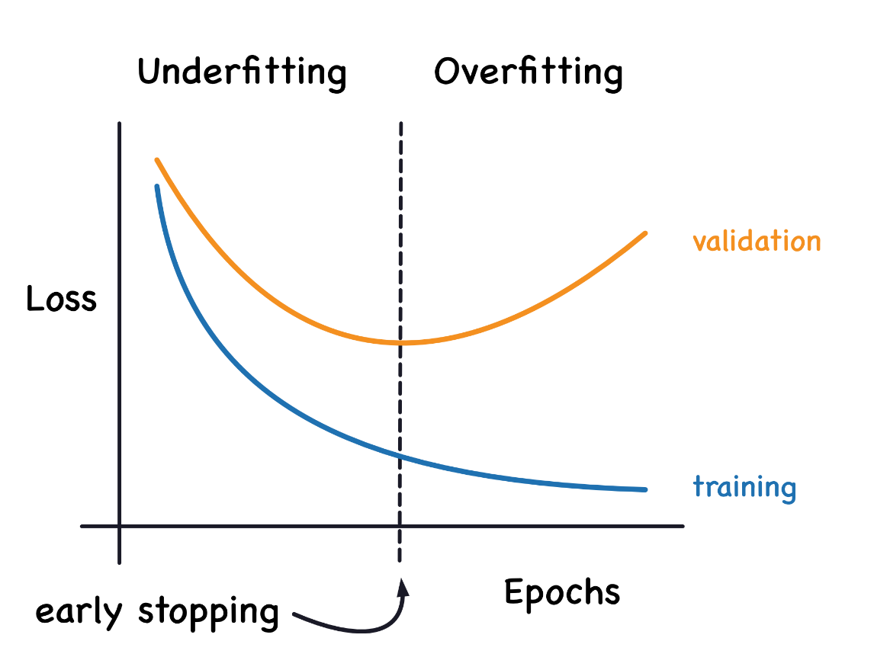

Accuracy and Cross-Entropy

**Accuracy** is one of the many metrics in use for measuring success on a classification problem. Accuracy is the ratio of correct predictions to total predictions: accuracy = number_correct / total. A model that always predicted correctly would have an accuracy score of 1.0. All else being equal, accuracy is a reasonable metric to use whenever the classes in the dataset occur with about the same frequency.

The problem with accuracy (and most other classification metrics) is that it can't be used as a loss function. SGD needs a loss function that changes smoothly, but accuracy, being a ratio of counts, changes in "jumps". So, we have to choose a substitute to act as the loss function. This substitute is the cross-entropy function.

Now, recall that the loss function defines the objective of the network during training. With regression, our goal was to minimize the distance between the expected outcome and the predicted outcome. We chose MAE to measure this distance.

For classification, what we want instead is a distance between probabilities, and this is what cross-entropy provides. **Cross-entropy** is a sort of measure for the distance from one probability distribution to another.

